The Eight (Osma, or Die Acht)
Eleanor Moseman, Colorado State University
Nicholas Sawicki, Lehigh University

Known in Czech as Osma and in German as Die Acht, the Eight was an artistic association at the forefront of the modern movement in Prague in the early twentieth century. It made a pivotal contribution to the development of post-impressionism, expressionism, and cubism in the Czech lands of the Habsburg Empire (Bohemia and Moravia), and first garnered attention through its exhibitions of 1907 and 1908. Bilingual in composition, the group included the artists Vincenc Beneš, Friedrich Feigl, Emil Filla, Max Horb, Otakar Kubín, Bohumil Kubišta, Willi Nowak, Emil Artur Pittermann-Longen, Antonín Procházka, and Linka Procházková. Other associations with the same name formed in Budapest and New York, but the Eight was the first to adopt the naming.

The nucleus of the Eight coalesced at the Academy of Fine Arts in Prague, where the majority of the group’s artists trained. Dissatisfied with the prevailing mode of academic realism in the school’s painting program and the conservative outlook of their teachers, many of the artists quit or were ejected from their studies. These departures precipitated the formation of the group, which took its name from the number of participants in its first exhibition. The exhibition opened in April 1907 in a rented storefront in Prague, and was followed by a second exhibition in June-July 1908 at the Topič Salon, a prominent local art gallery. Breaking with the local custom of artists showing their work with established artistic institutions, the two exhibitions were independently organized and promoted by the Eight, and they showcased the group’s rupture with academic tradition.

The founding members of the Eight gradually replaced academic naturalism with a loose, expressive treatment of line invested with psychological intensity, and colour imbued with symbolic meaning. Their subjects included portraits; landscapes and city scenes; religious, mythological, and literary imagery; still lifes; and genre scenes depicting modern life’s labour and amusements. The style of their work was reminiscent of the art of Paul Cézanne, Paul Gauguin, Henri Matisse, Edvard Munch, and Vincent Van Gogh, which the Eight followed closely. Early exposure to Auguste Rodin’s sculpture and especially Munch’s paintings through exhibitions in Prague (1902 and 1905 respectively) set the artists of the Eight on their expressive trajectory. Reviews of the latter exhibitions and commentaries on art from abroad by Czech critics and art historians were regularly published in the Prague art journal Volné směry (Free Directions), and had a decisive impact on the Eight. The journal was published by the Mánes Association, a progressive Czech organization for artists where several members of the Eight later sought membership.

The painted imagery of the Eight exposed the dissolution of belief in stability among a populace weary of Habsburg rule. Ethnic, religious, and class tensions visible in contemporary Prague often manifested in the art world in the form of separate exhibition groups based on language. Outright violence occasionally erupted between mobs of Czech- and German-speakers, as the fissures in a decadent empire began to show. In contrast to this divisiveness, however, the Eight radically brought together artists of both Czech and German backgrounds, Christian as well as Jewish.

Local audiences and critics were scandalized by the group’s mixed ethnic composition, and perceived the art of the Eight as a threat to academic conventions. The two exhibitions that the Eight organized were beset by negative reviews. Even the progressive-minded brothers Josef and Karel Čapek published a mixed response, which criticized the paintings’ amorphous quality and commented on the Eight artists’ eye for colour and light along with their ability to evoke the spiritual. The group nevertheless found support for its efforts, most notably from within the Prague literary world, and from critics such as Max Brod and František X. Šalda. Brod wrote the first major article on the Eight, a response to the group’s inaugural exhibition titled “Frühling in Prag” (“Spring in Prague,” 1907).

The Eight maintained close contact with gallerists and artists in Berlin, Vienna, and Paris, including Paul Cassirer, Julius Meier-Graefe, and the Brücke in Germany, as well as Henri Matisse and André Derain in Paris. In 1910 the Eight helped organize the Prague debut of Derain and Matisse, as well as Georges Braque, at an exhibition hosted by the Mánes Association and titled “Les Indépendants,” which first brought key examples of Parisian post-impressionist and cubist painting to local attention. The Eight gradually dissolved that same year. Several of its members reunited in 1911 to establish the Group of Fine Artists (Skupina výtvarných umělců), widely represented in scholarship as a successor to the Eight.

References and Further Reading

Anděl, Jaroslav, et al. Czech Modernism, 1900-1945, exh. cat. Houston Museum of Fine Arts (Boston: Bulfinch Press, 1989).

Benson, Timothy O. and Éva Forgács, eds. Between Worlds: A Sourcebook of Central European Avant-Gardes, 1910-1930 (Cambridge, Mass.: MIT Press, 2002).

Brod, Max. “Frühling in Prag.” Die Gegenwart (18 May 1907), 316-317.

Clegg, Elizabeth. Art, Design, and Architecture in Central Europe, 1890-1920. New Haven: Yale University Press, 2006.

Lamač, Miroslav. Osma a Skupina výtvarných umělců, 1907-1917 (Prague: Odeon, 1988).

Mansbach, Steven A. Modern Art in Eastern Europe: From the Baltic to the Balkans, ca. 1890-1939 (Cambridge: Cambridge University Press, 1999).

Padrta, Jiří with Miroslav Lamač. Osma a Skupina výtvarných umělců – 1907-1917: Teorie, kritika, polemika (Prague: Odeon, 1992).

Pomajzlová, Alena, ed. Expresionismus a české umění 1905-1927 [Expressionism and Czech Art] (Prague: Národní Galerie, 1994).

Sawicki, Nicholas. “The Critic as Patron and Mediator: Max Brod, Modern Art, and Jewish Identity in Early Twentieth-Century Prague.” Images: A Journal of Jewish Art and Visual Culture 6 (2012), 30-51.

Sawicki, Nicholas. Na cestě k modernosti: Umělecké sdružení Osma a jeho okruh v letech 1900-1910. Prague: Filozofická fakulta Univerzity Karlovy, 2014.

Relevant Websites

National Gallery in Prague, Collection of 19th and 20th-century art
http://www.ngprague.cz/en/5/sekce/veletrzni-palace/ (significant number of works by the Eight artists)

The Gallery of West Bohemia in Pilsen
http://www.zpc-galerie.cz/cs/collections (works by artists of the Eight’s generation)

Museum of Modern Art in Olomouc
http://www.olmuart.cz/MMU/ (works by artists of the Eight’s generation)

Topič Salon in Prague
http://www.topicuvsalon.cz/index.php?option=com_content&view=category&layout=blog&id=50&Itemid=89 (site of 2nd exhibition of the Eight, 1908)

History of S.V.U. Mánes (1887-2007)
http://www.svumanes.cz/ospolku.html (from a documentary exhibition; text by Jindřich Bořecký, Lucie Gočárová, and Václav Špale)

Suggested images

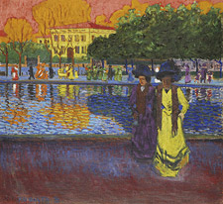
Bohumil Kubišta, Promenáda u Arna (Promenade on the Arno), 1907, oil on board. Gallery of West Bohemia in Pilsen. Image in the public domain.

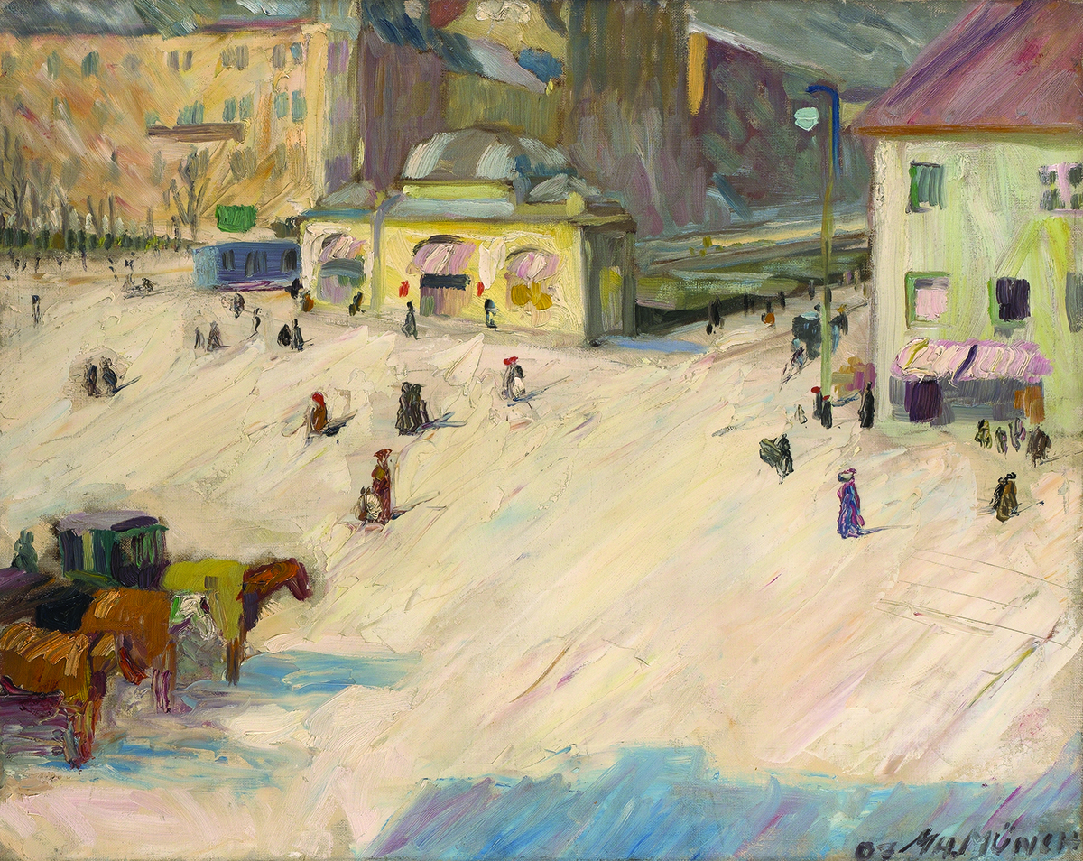
Max Horb, Platz in München (Square in Munich), 1907, oil on canvas. Shown at the first exhibition of the Eight, 1907. National Gallery, Prague. Image in the public domain.

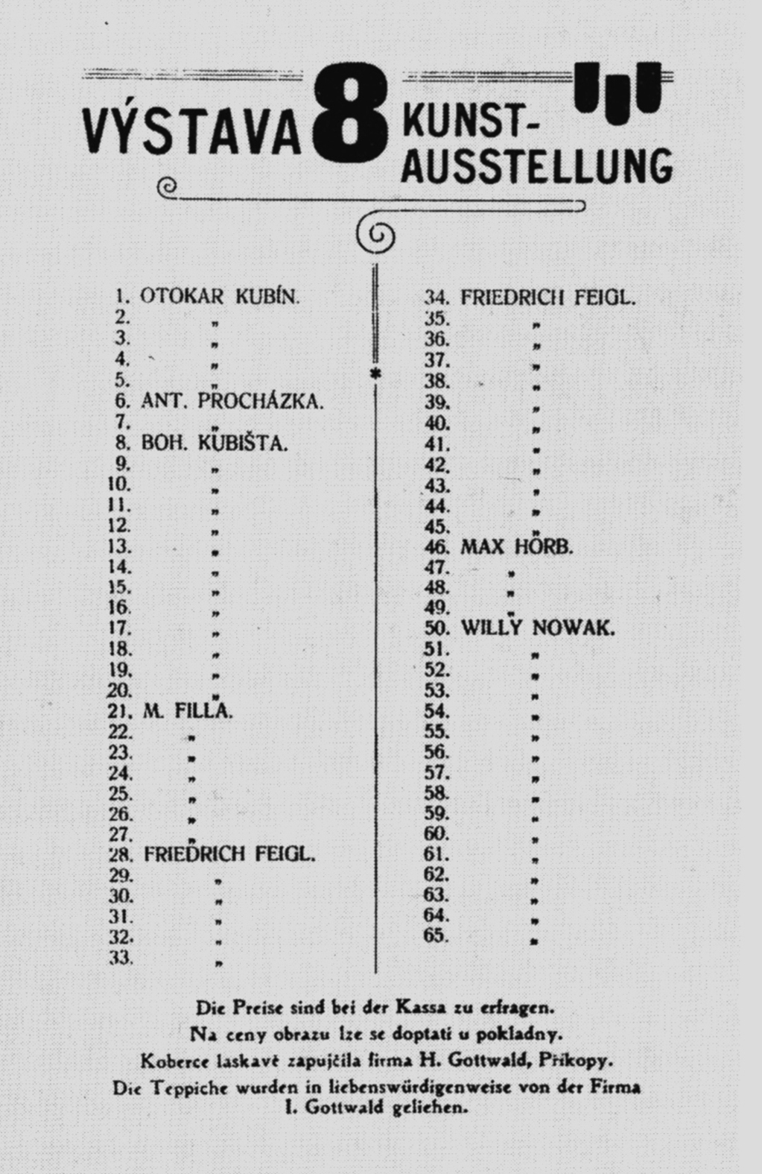
Broadside catalogue of the first exhibition of the Eight, Prague, 1907. Image in the public domain.

